1.С **mobi-shop** отошлите на **laravel-shop** несколько сообщений от разных пользователей (см.таблицу **users – api_token**):

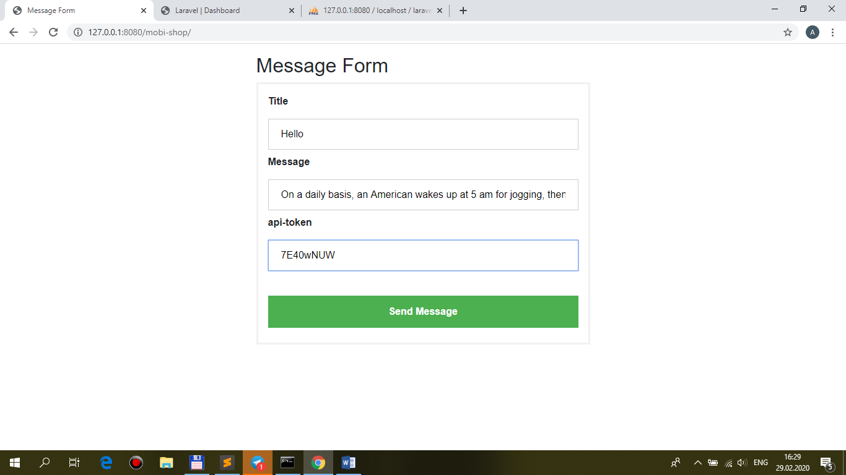

+ views/front/**messages/index.blade.php** **@include('front.messages.brick-standard') + подкорректируйте front/messages/brick-standard** для получения такого вывода:

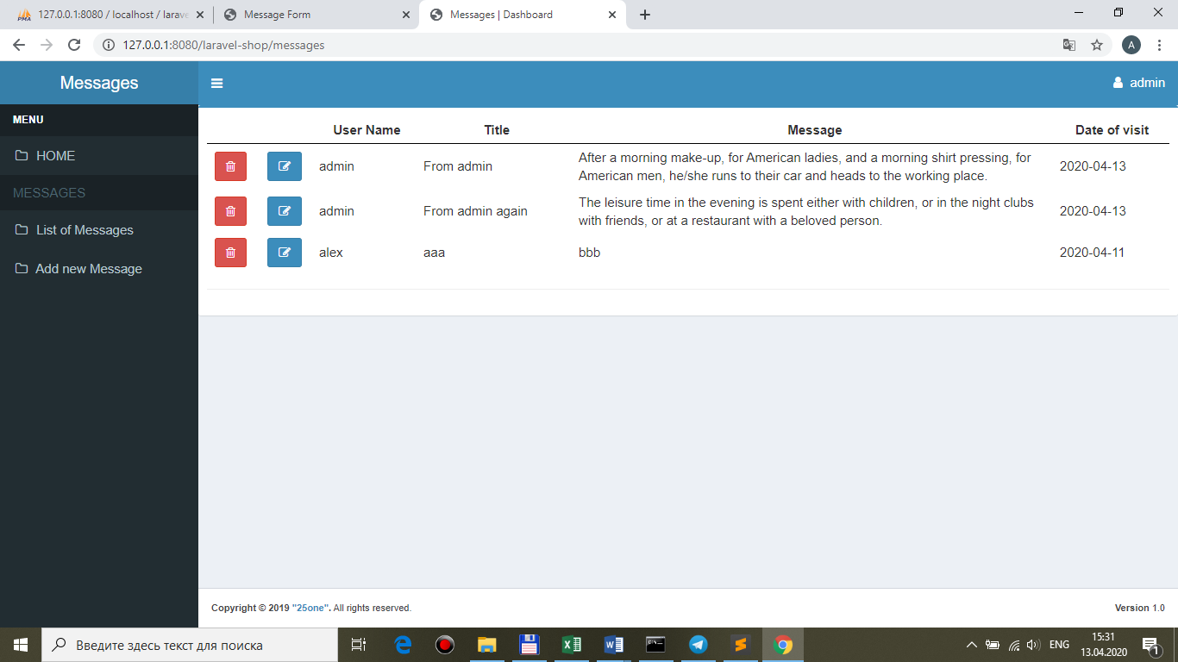

@foreach(**$messages as $message**)

<tr>

<td class="center widthbutton"><a class="btn btn-danger **listbuttonremove**" **id="{{$message->id}}"** href="#"><i class="fa fa-trash-o" aria-hidden="true"></i></a></td>

<td class="col-md-6 col-sm-6 col-xs-6 center widthbutton"><a class="btn btn-primary listbuttonupdate" href="#"><i class="fa fa-edit" aria-hidden="true"></i></a></td>

**<td>{{ $message->user->name }}</td>**

**<td>{{ $message->title }}</td>**

**<td>{{ $message->message }}</td>**

**<td>{{ $message->datevisit }}</td>**

</tr>

@endforeach

2.Разместите на странице **текстовое поле** и **кнопку** для **поиска по контексту** в **message**:

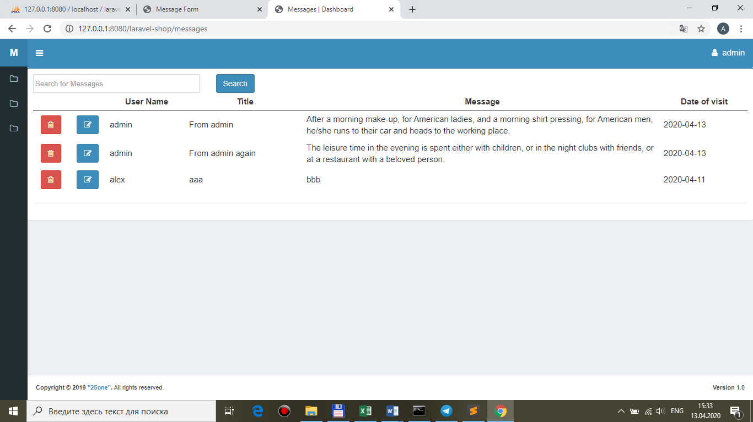

**<div class="row">**

**<div class="col-md-3 col-sm-3 col-xs-8">**

**<input type="text" class="form-control search_text" placeholder="Search for Messages" />**

**</div>**

**<div class="col-md-3 col-sm-3 col-xs-4">**

**<button type="button" class="btn btn-primary search_button">Search</button>**

**</div>**

**</div>**

<div class="table-responsive">

@if (session('message-updated'))

@component('back.components.alert')

@slot('type')

success

@endslot

{!! session('message-updated') !!}

@endcomponent

@endif

…

3.Реализуйте **ajax**-поиск **по контексту** по полю **message**:

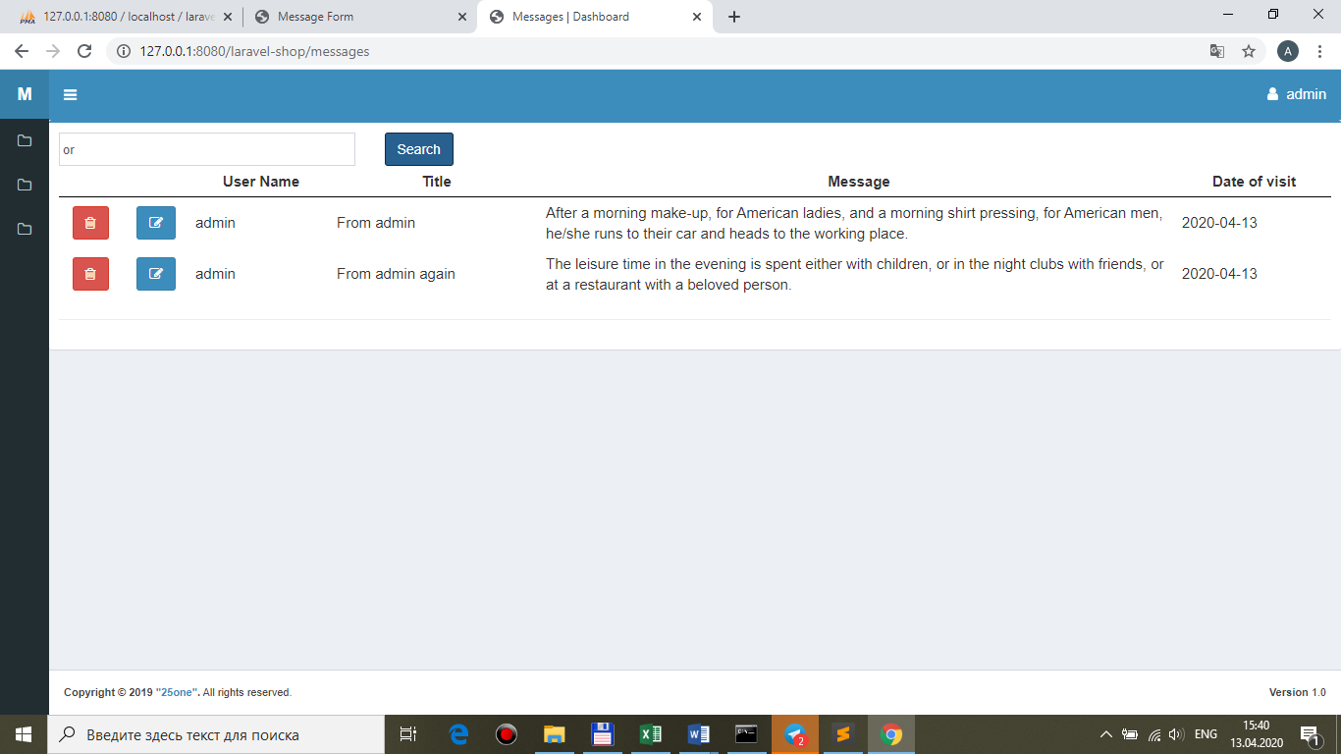

**views/front/messages/index.blade.php**

…

@section('js')

<script>

**$(document).ready(function(){**

**$('.search_button').click(function(){**

**BaseRecord.searchMessages($('.search_text').val());**

**});**

**});**

</script>

@endsection

**public/main.js**

searchMessages: function(**search_messages**){

//alert(value);

var ajaxSetting={

**method: 'get',**

**url: './messages',**

**data: {**

**search_messages: search_messages,**

**},**

success: function(data){

//alert(data.table);

**$('#pannel').html(data.table);**

},

};

$.ajax(ajaxSetting);

},

**MessageController.php**

public function index(**Request $request**)

{

$messages = $this->repository->funcSelect($request);

**// Ajax response**

**if ($request->ajax()) {**

**return response()->json([**

**'table' => view("front.messages.brick-standard", ['messages' => $messages])->render(),**

**]);**

**}**

return view('front.messages.index', ['messages' => $messages]);

}

**MessageRepository.php**

public function funcSelect($request)

{

$query = $this->model_message

->select('id', 'user_id', 'title', 'message', 'datevisit')

->orderBy('datevisit', 'desc');

**if($request->search_messages) $query->where('message', 'like', '%' . $request->search_messages . '%');**

return $query->get();

}